Experiment - 6
Operating Systems Lab
Syeda Reeha Quasar
14114802719
6C7
AIM
To write the following shell programs:
- Shell script to calculate factorial of a number.
- Shell script to print Fibonacci series up to given number.

EXPERIMENT – 6

Aim:
To write the following shell programs:
- Shell script to calculate factorial of a number.
- Shell script to print Fibonacci series up to given number.

Source Code:

Write a shell script to calculate the factorial of a number:

echo "Enter a number"
read n
num=$((n))

fact=1

while [ $num -gt 1 ]
do
fact=$((fact * num)) #fact = fact * num
num=$((num - 1)) #num = num - 1
done

echo "Factorial of $n is: $fact"

Output:

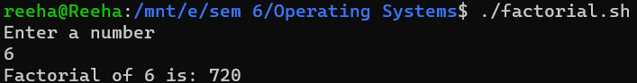
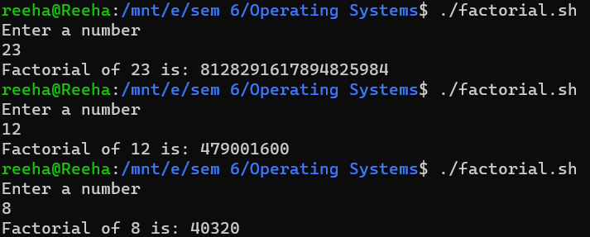

Write a shell script to print the Fibonacci series up to the given number:

echo "How many Fibonacci series numbers do you want to list? "
read n
a=0
b=1
count=2
echo "Fibonacci series upto $n terms:"
echo $a
echo $b
while [ $count -le $n ]
do
fib=`expr $a + $b`
a=$b
b=$fib
echo $fib
count=`expr $count + 1`
done

Output:

